phone: [920] 830-2510  N225 stoney brook road  appleton, wi 54915  email: gamedaysportsbar@outlook.com  www.gameday-sportsbar.com | 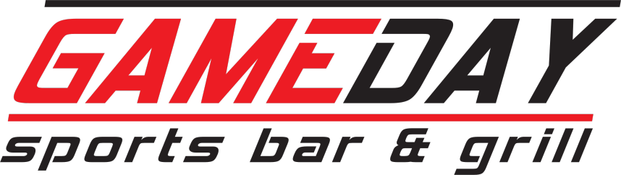

event policy and procedures
- all guests must be 21 years or older for all bar events
- guests under the age of 21 are welcome for dinner events, but must leave after dinner or by 9pm, whichever comes first
- no food or beverages are allowed to be brought in to gameday sports bar, with the exception of a cake / dessert from a licensed bakery
- decorations are allowed, but confetti or glitter of any kind or size is prohibited
- any damage to the bar area that is caused by guests of an event will be the responsibility of the person in charge of the event
- all parties are subject to Wisconsin state tax (5.5%) and gratuity (20%)
- all food orders must be received at least seven days prior to the event
- all cancellations must be made two weeks prior to the date of the party, or you will forfeit your rental fee
event info
name _______________________________ date of party ______________________
company name _________________________
phone # ____________________
type of event _____________________________
# of adults __________ # of kids ______________
time of party arrival _______________ time of food service _______________
rental fee $ __________
area reserved :
- party room (inside)
- outdoor bar
- covered patio
- cabanas
- volleyball courts

customer signature / date

GameDay employee signature / date

TRAYS / DIPS / APPS
-items feed approx. 20 people-

- taco dip w/tortilla chips $40
- cheese & sausage w/crackers $50
- lil’ smokies $45
- bbq meatballs $50
- fresh fruit tray $55
- seasonal veggie tray w/dip $45
- french onion dip w/chips $35
- salsa w/tortilla chips $25
- beer dip w/pretzels $35
- buffalo chicken dip w/chips $45
- spinach dip w/tortilla chips $40

WINGS
-available in boneless or traditional-
-includes ranch-
-one flavor per 25 wings-

- flavor(s): ____________________
$50 (50) $90 (100)
boneless -or- traditional

SAUCES: doa / hot / bobs / hot garlic / gold fever / honey hot / mango habanero / mild / buffalo / acs / honey bbq / regular bbq / teriyaki / creamy garlic parmesan
DRY RUBS: garlic parmesan / cajun / lemon pepper / jamaican jerk

BEER
-domestic only / ask for pricing on craft beer selection-

- ¼ barrel (15 pitchers) $140 _______
- ½ barrel (30 pitchers) $270 _______

PARTY PACKAGES
-minimum 20 people each-

- FIESTA BAR $14 per person [minimum 20 per meat choice]
lettuce / tomato / onion / cheese / jalapenos / salsa / sour cream / soft shell tortillas
  - chicken fajita _____________
  - beef barbacoa _____________

- TAILGATER $14 per person ________
brats / burgers / buns / cheese / lettuce / tomato / onion / pickle / condiments / potato salad or coleslaw / potato chips w/french onion dip

- GAME PLAN $15 per person ________
choose two meats: pulled pork – hot ham – hot turkey - hot beef / buns / condiments / potato salad or coleslaw/ potato chips w/french onion dip

- SAFETY $13 per person _________
cold cuts [ham & turkey] / buns / cheese / lettuce / tomato / onion / pickle / condiments / potato salad / potato chips w/french onion dip

- PIZZA/SALAD $12 per person_____
Featuring a variety of one topping and specialty pizzas with house salad and 2 dressing choices.
**add wings for an additional $4/person
2 wing flavor choices, choose from boneless or traditional served with ranch

***prices subject to change***
revised 03/2025

